RENEWED HOPE FRONTIER PROGRAMME
Border Communities and National Development
Assessing the Vulnerabilities, Challenges, and Development Needs of Disadvantaged and Sensitive Communities
EXECUTIVE SUMMARY · A proposal to Her Excellency the First Lady of the Federal Republic of Nigeria

Nigeria does not end at her borders. Nigeria begins there.

The situation
Nigeria shares 3,053 km of land border with Benin, Niger, Chad and Cameroon. Along it lie more than 2,000 border communities in 105 LGAs across 21 States — over 20 million Nigerians, roughly 14% of the population, and more people than live in Lagos State.
These communities are the first to meet what crosses into Nigeria and the last to receive what Nigeria provides. Mothers cross international boundaries to deliver their babies. Children cross to attend school and return speaking a foreign language. Families cross to fetch water. The Senate has called the consequence a crisis of allegiance. A ₦50 billion appropriation exists; what is missing is a georeferenced picture of where the need is, and a vehicle able to carry help the last ten kilometres.

The proposal
The Renewed Hope Frontier Programme — a flagship initiative of the Renewed Hope Initiative under the leadership of Her Excellency the First Lady — has two halves, and the first makes the second possible.
- ASSESS. Build the Frontier Vulnerability Index and the National Frontier Register: the first authoritative, georeferenced, community-by-community measurement of vulnerability across all 2,000+ border communities. Nigeria has never had one.
- TRANSFORM. Deliver a costed, sequenced package through five pillars — the Frontier Mother & Child Corridor; Water, Light and Learning; Livelihoods and Border Markets; Identity and Belonging; and Frontier Health Coverage — beginning with a 100-Day Frontier Compassion Sprint in one community in every border State.

What makes it different
- Targeting by evidence, not advocacy. Every community scored and fixed to GPS coordinates before a naira is committed.
- Delivered by frontier women. A trained, paid cadre of Frontier Hope Ambassadors resident in each community — delivery mechanism, accountability mechanism and empowerment intervention at once.
- Technology already built, and Nigerian. Health screening, maternal support and outbreak reporting over WhatsApp, SMS and basic handsets in local languages.
- Public proof of delivery. Geotagged, photographed, timestamped completion on an open dashboard any Nigerian can inspect.
- Built to outlast the launch. Frontier households are enrolled into the NHIA’s existing Vulnerable Group Fund — but only after the facility is equipped, staffed and accredited. Enrolment is not coverage; a card is worthless where the clinic has no water.
- A headline metric nobody else reports. The Cross-Border Dependency Rate — the proportion of households that must leave Nigeria to meet a basic need. Target: down 50% in 24 months, 80% in 60 months.

It is also epidemic preparedness
Cholera, meningitis and diphtheria return to these communities every season — Borno alone has recorded over 4,000 suspected cholera cases this year, and the NCDC names the cause as absent potable water and sanitation. When an outbreak arrives the preconditions for responding are missing: you cannot treat cholera without clean water, vaccinate without power for a cold chain, count children who were never registered, isolate patients where there is no clinic, or trace contacts down a road that floods.
No additional line item is required. Every asset already in this Programme does one job on an ordinary day and another on the worst day — the borehole interrupts cholera at source, the mini-grid runs the vaccine refrigerator, the registration point supplies the denominator a campaign needs. Nigeria will spend this money either way; the only question is whether before the outbreak or after it.

Alignment
The Programme contributes to seven of the President’s eight priority areas and to all five Renewed Hope Initiative pillars. It extends two initiatives Her Excellency has already championed — the birth registration drive and the campaign against cervical cancer — to the one geography they have not reached.
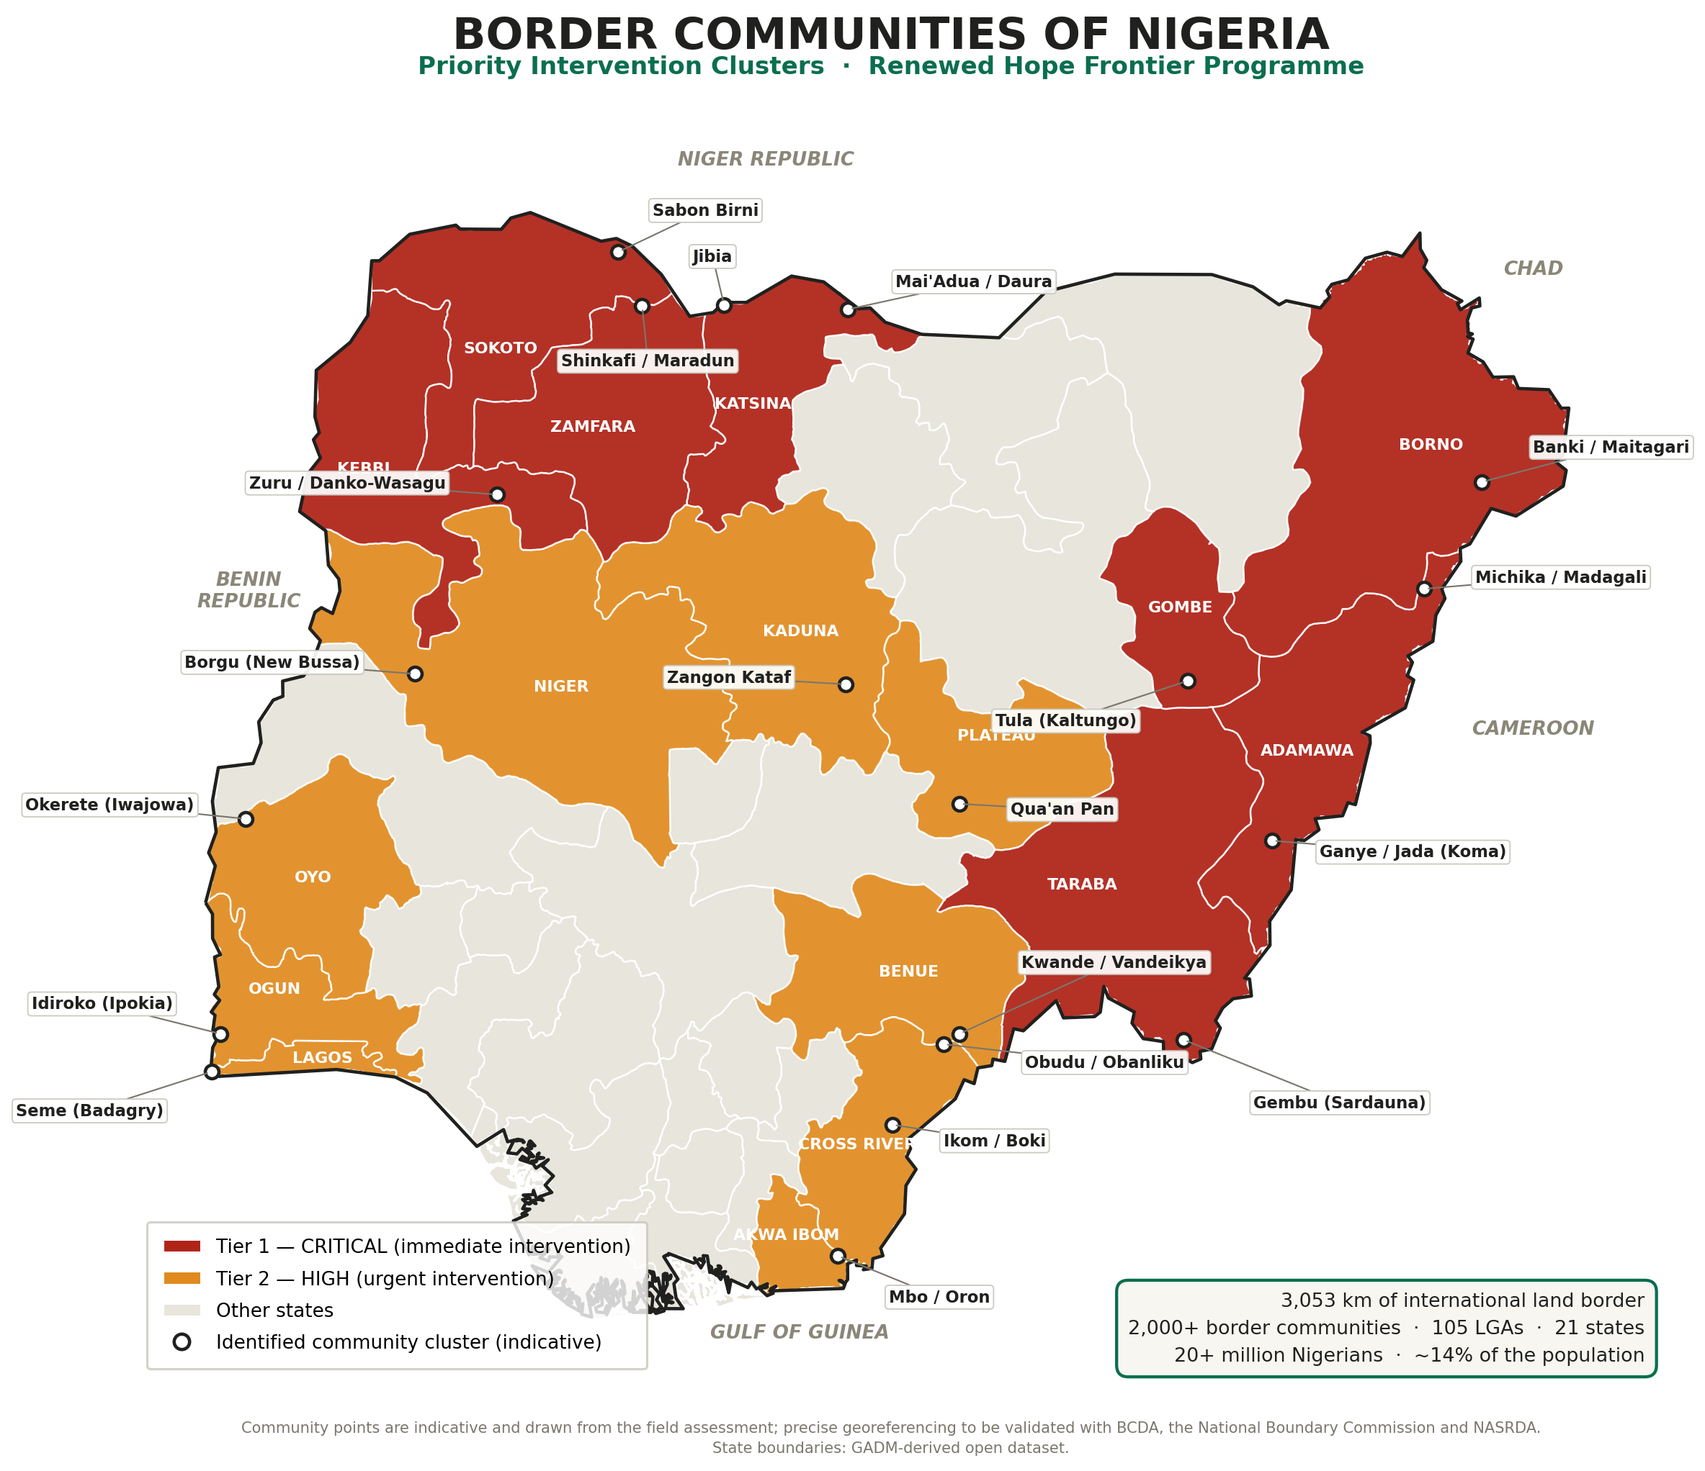
Priority intervention clusters. Tier 1 (red): immediate. Tier 2 (amber): urgent.

Investment and phasing
Phase | What it delivers | Investment | Timeline
0 | Frontier Assessment: the FVI instrument, field assessment in 21 sentinel communities, the National Frontier Register, the public dashboard and the costed national plan | ₦30 million | Months 0–6
1 | 100-Day Frontier Compassion Sprint — a full package in 21 communities, one per border State | ₦2.4 billion | Months 4–9
2 | Renewed Hope Frontier 250 — the 250 highest-need communities | ₦21 billion | Months 9–33
3 | National coverage of 2,000+ communities, blended with Federal, State and partner funding | ₦180 billion | Years 3–8
Only Phase 0 is requested now. Phase 1–3 figures are indicative, to be validated in Phase 0.

100-day targets
21 communities · 500,000 people reached · 21 solar boreholes · 21 primary health centres equipped · 50,000 births registered · 525 frontier women trained and earning · 21 State launches hosted by Governors’ Spouses

The ask
- Adopt the Renewed Hope Frontier Programme as a flagship initiative of the Renewed Hope Initiative.
- Approve ₦30,000,000 for Phase 0 — the six-month Frontier Assessment.
- Constitute the Frontier Programme Council under Her Excellency’s chairmanship.
- Invite the Nigeria Governors’ Spouses Forum to designate a State Frontier Patron in each of the 21 border States.
- Receive the findings at a National Frontier Summit in month six, launching the 100-Day Sprint.
Every First Lady of Nigeria is remembered for one thing. This is an opportunity to be remembered as the First Lady who went to the edge of the country and brought twenty million Nigerians back into the picture.

